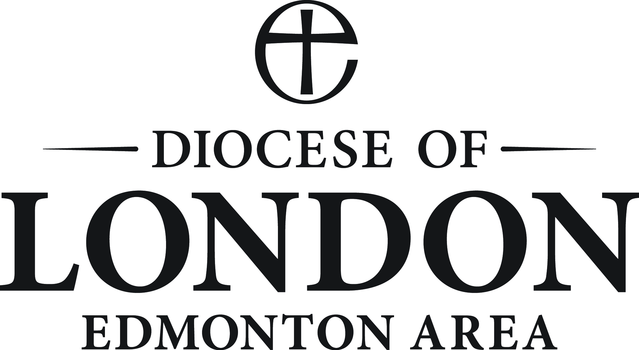
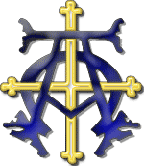
THE PARISH CHURCH OF
EMMANUEL, WEST HAMPSTEAD

APPLICATION FOR BAPTISM

Child’s Christian names

Surname

Child’s date of birth

Address

Telephone number

Father’s full name |  | Baptised ? Yes / No  Confirmed? Yes / No
Mother’s full name |  | Baptised ? Yes / No  Confirmed? Yes / No
Father’s occupation

Mother’s occupation

Godparent’s full names | There may be three or four Godparents  all of whom should themselves be baptised
1.

2.

3.

4.

Parent’s declaration | We ask for Holy Baptism for our child and will do our best to  bring him / her up as a member of the Church
Father’s signature

Mother’s signature

There is no fee for Holy Baptism,

but a voluntary thank offering to the Church will be very gratefully received.

We much look forward to welcoming your child as a member of the Church - which is Christ’s Body throughout the world. Emmanuel is your Parish Church and we are here for you. A very warm welcome awaits you all at any of our Sunday Services:

0800 Eucharist (said)
0845 Morning Prayer (said)
0915 Joyful Noise Eucharist
our more informal service - especially suitable for very small children, lasting 35-40 minutes

1030 Sung Eucharist
our more traditional service lasting around 60 minutes, at which children are still very welcome
Children’s Church for children four years old and above meets in term time during the service

020 7435 1911 info@emmanuelnw6.com
www.emmanuelnw6.com

